# **OSSEC Implementation Report**

## **Ubuntu Linux 22.04 Desktop**

### **Prerequisites Installation**

sudo apt update

sudo apt install build-essential gcc make unzip sendmail inotify-tools expect libevent-dev libpcre2-dev libz-dev libssl-dev libsystemd-dev

**Output:**

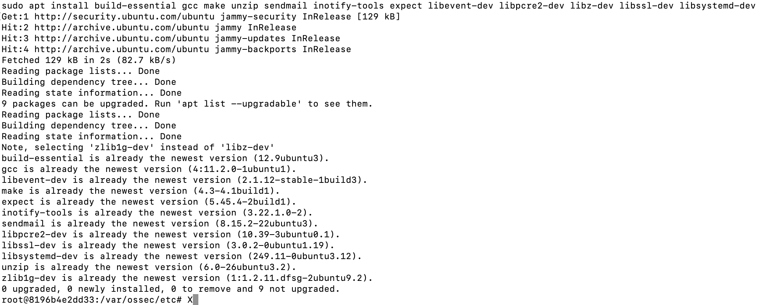

### 

### 

### 

### 

### 

### 

### 

### **Downloading OSSEC**

sudo wget -P /opt https://github.com/ossec/ossec-hids/archive/3.7.0.tar.gz

**Output:**

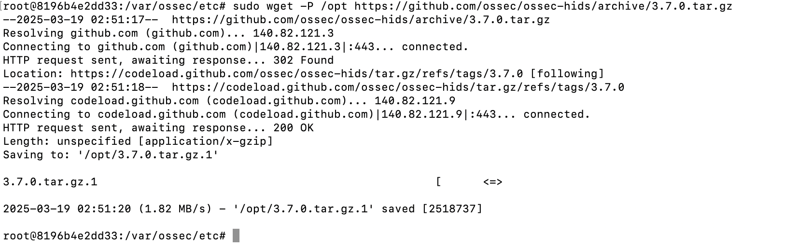

### **Extracting OSSEC**

sudo tar -zxf /opt/3.7.0.tar.gz --directory /opt



### **Running the Installation Script**

sudo sh /opt/ossec-hids-3.7.0/install.sh

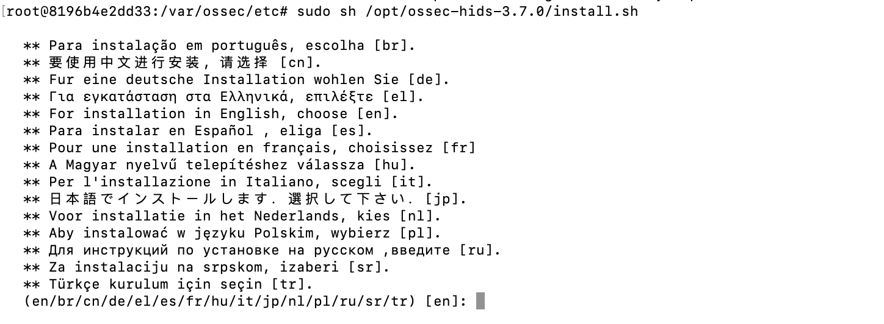

### **Exploring the Configuration**

cd /var/ossec/etc

sudo gedit ossec.conf

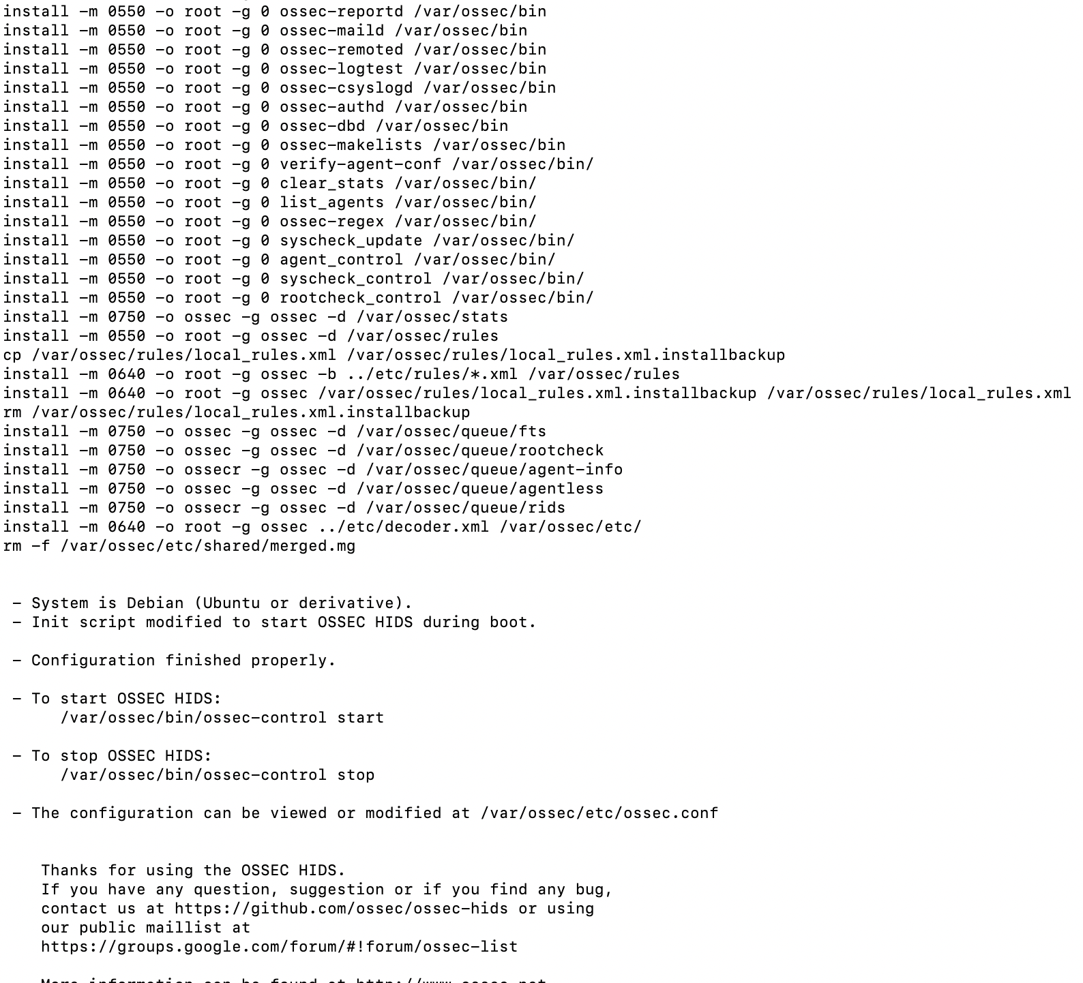

### **Starting OSSEC**

sudo /var/ossec/bin/ossec-control start

**Output:**

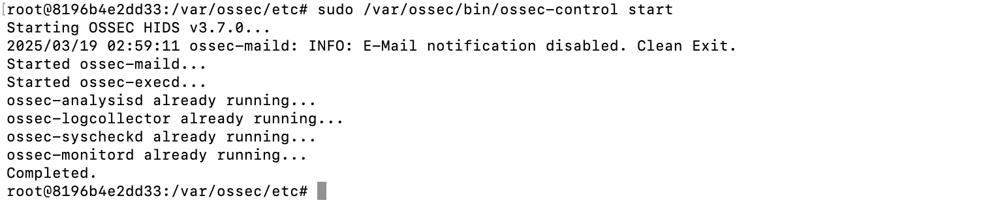

### **Verifying OSSEC Status**

sudo /var/ossec/bin/ossec-control status

**Output:**

